Report SWI-TEC Hydro Charger on RM 1260 Vitamina
Cap Finistere-Cabo Sao Vicente end May 2013, by Domingo Zaengerle, Schnufao S/Y RM 1200
Finally we had good winds NW 4-5 but with waves around 5 meters coming down to 3 meters near Cabo Sao Vicente. Vitamina was running steadily between 7 and 10 knots with Main and Genoa; in the reinforcing wind condition several times we reached over 14 knots in the surfs. We steered in the beginning, the Garmin autopilot was still not well adjusted and made a zig zag in the big waves.
The battery bloc of 4 x 110 Ah in total 440Ah started with 13,1 V in Cap Finistere and came down to 12 V when we started the engine after Cabo Sao Vicente.
The SWI-TEC Hydro Charger was loading the most of the time;
8 knots of speed 100-150 Watts or 8 to 12 Amp, 85 % of the trip time
9 knots 150-250 Watts or 12 to 20 Amp, 15 % of trip time average 11,3 Amp
10 knots 250-350 Watts or 20 to 29 Am, spotwise
We travelled three days with the power of the hydro charger, only the tension came slowly down, but after an analysis of the consumption, Navtex, VHF, 2 Plotters, GPS, Autopilot, Inverter, Radio, Freezer and Lights, around 13 Amp average, it was clear the consumption was a little higher, 1,7 Amp, as the power of the hydro charger with this type of propeller. But anyway we could travel without charging with the diesel engine over the whole distance during aprox. three days. The next step would be to reduce the consumption, stopping one plotter, reducing the freezer, stopping the Navtex, but desafortunately the wind came down and we had to start the engine. Knowing now the charging parameters of Vitamina we will change the actual propeller with a propeller with less pitch, to increase the charging power with less speed, but with a little bit more drag.
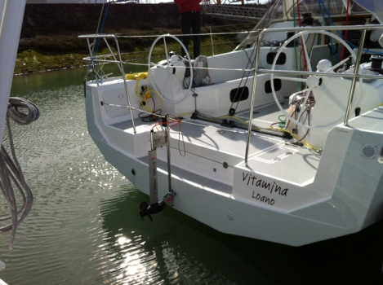 Mounting on transom
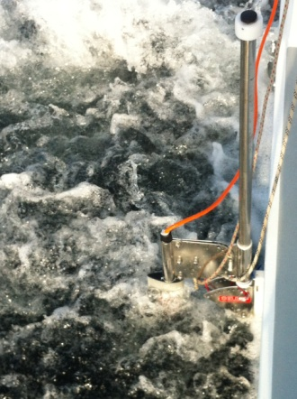 Hydro Charger at work 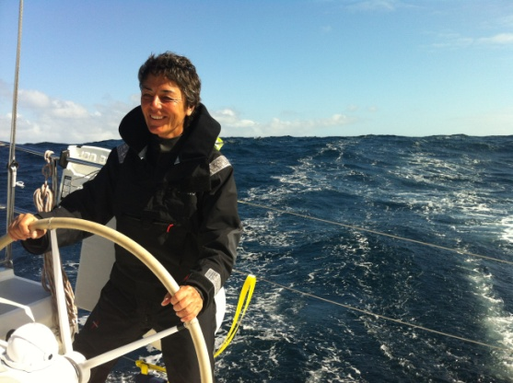 Surfing

